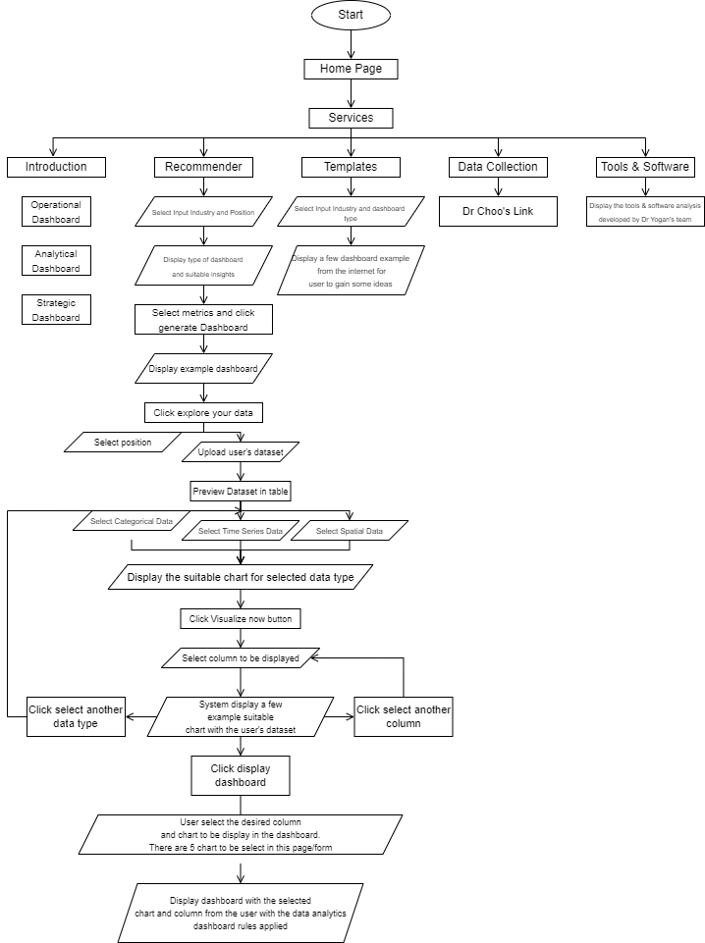

**Recommender Flow’s**

1. User select industry and position input to determine the dashboard type and suitable metrics will be displayed.

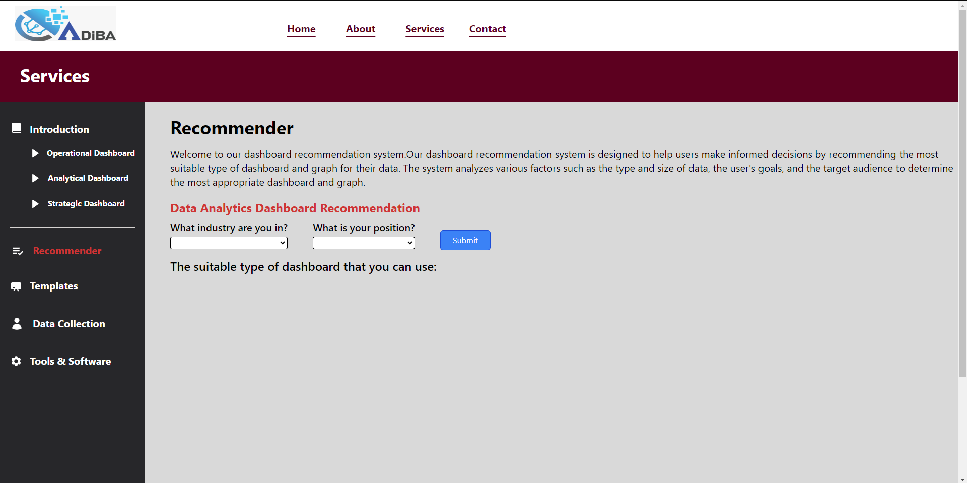

1. User can select which metric they want to see the detailed explanation.

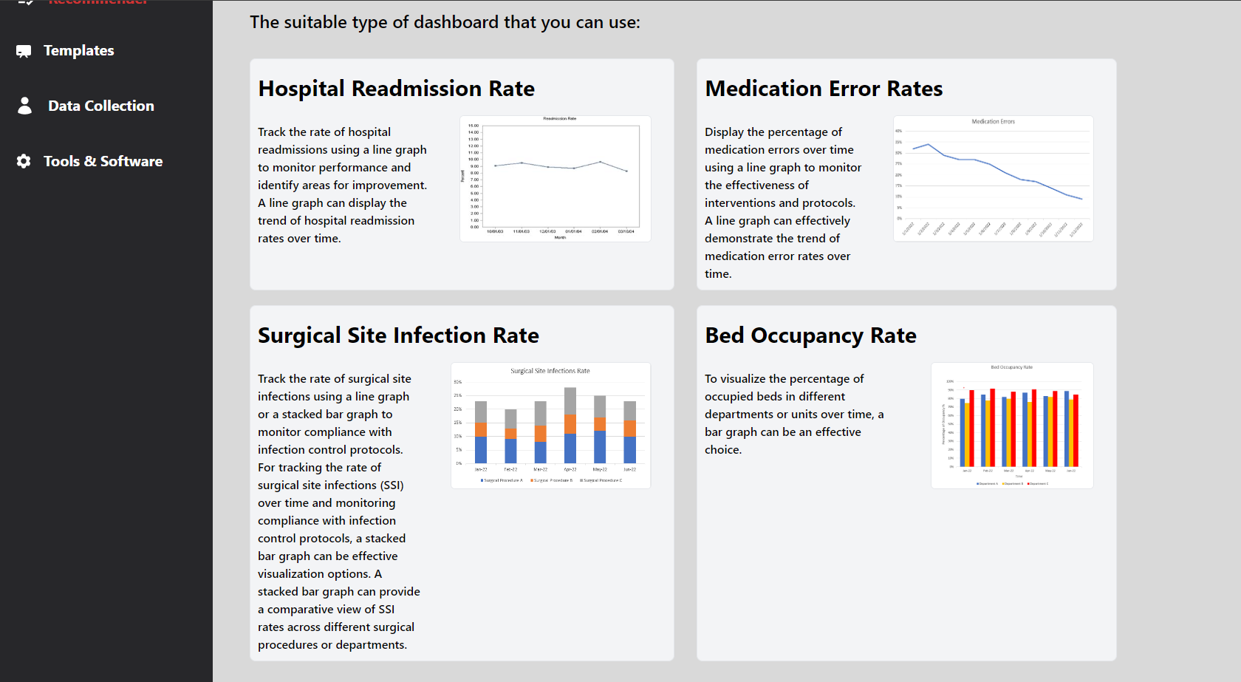

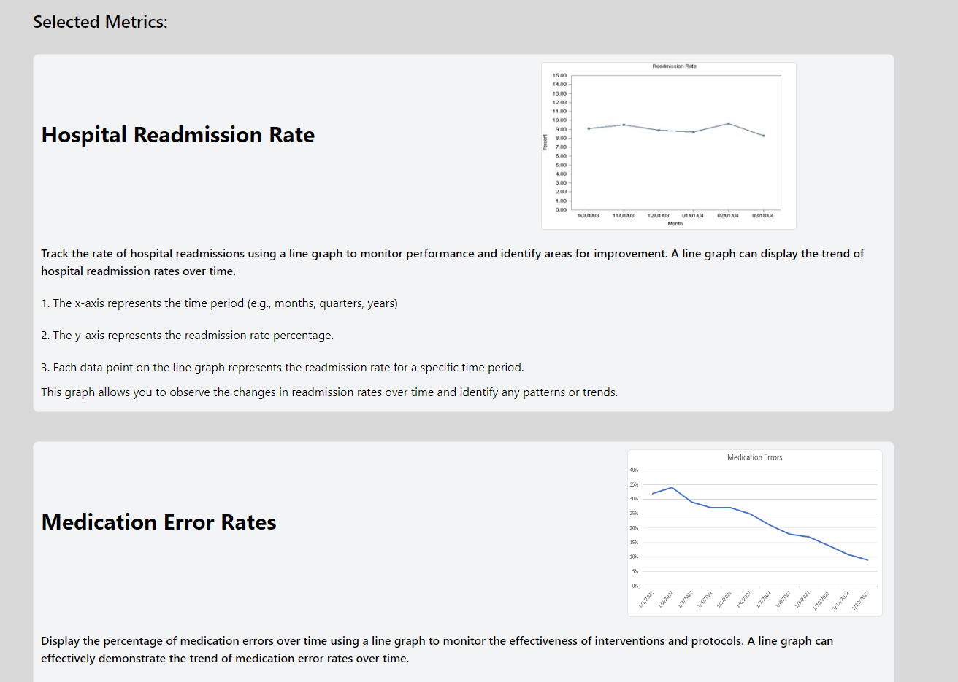

1. User click generate dashboard button to see the graph in the dashboard layout.

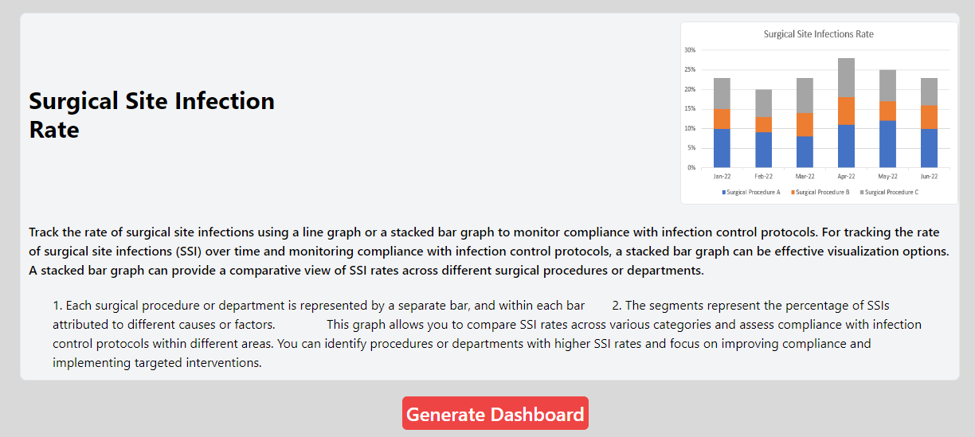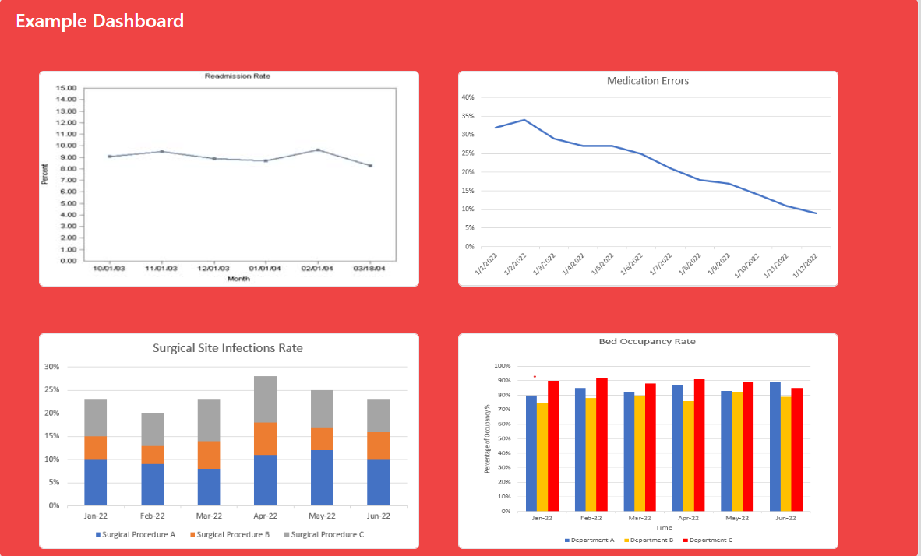

1. Then, user can click “Use your real data” button to try with their dataset.



1. User can choose their target user for the dashboard and then upload their dataset.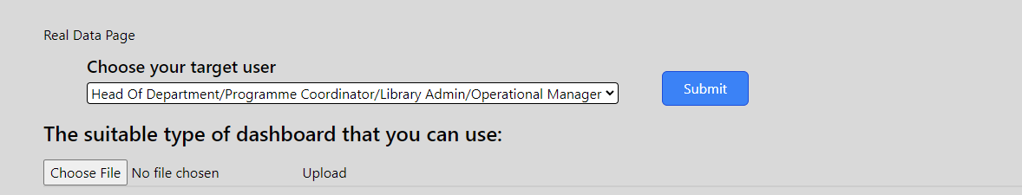
2. After the user upload their file, then the system will preview their data in table. Then click next step to go to the next page.

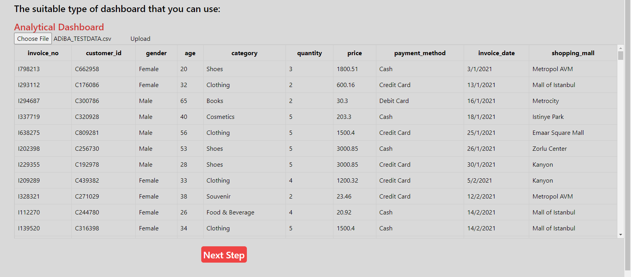

1. On the next page, user have to choose what data type that they had in their dataset.

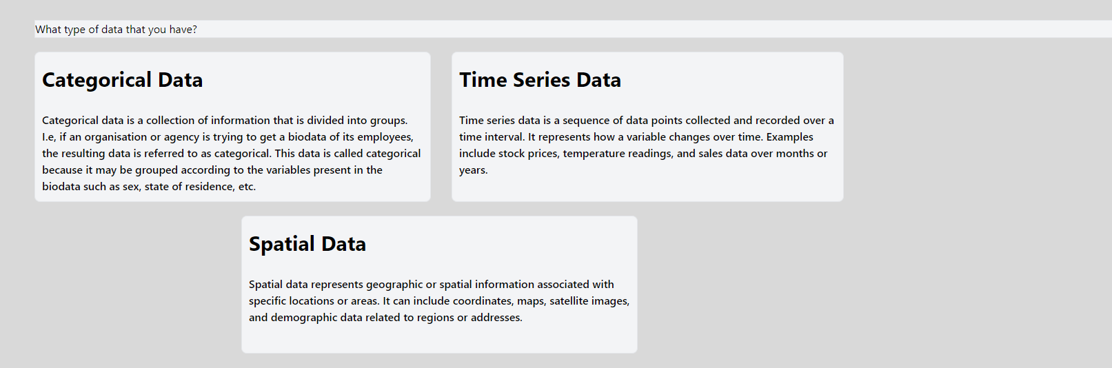

1. Then if user select categorical data, then there will be a few graphs that suitable to be used with categorical datatype and its explanation. Below the explanation, have one button Visualize your data.

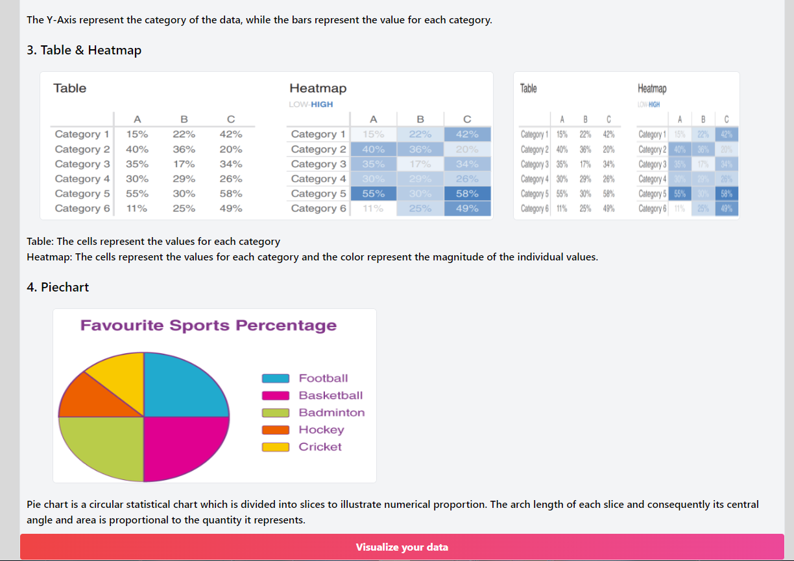

1. Then, user have to select the column from their dataset that they want to display in the graph.

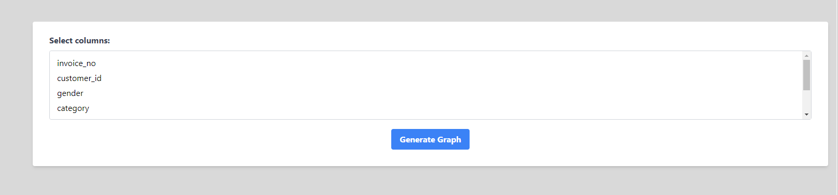

1. After user click generate graph, then system will show the suitable graph with their selected column in the dataset as preview the appearance of their graph that can be used.

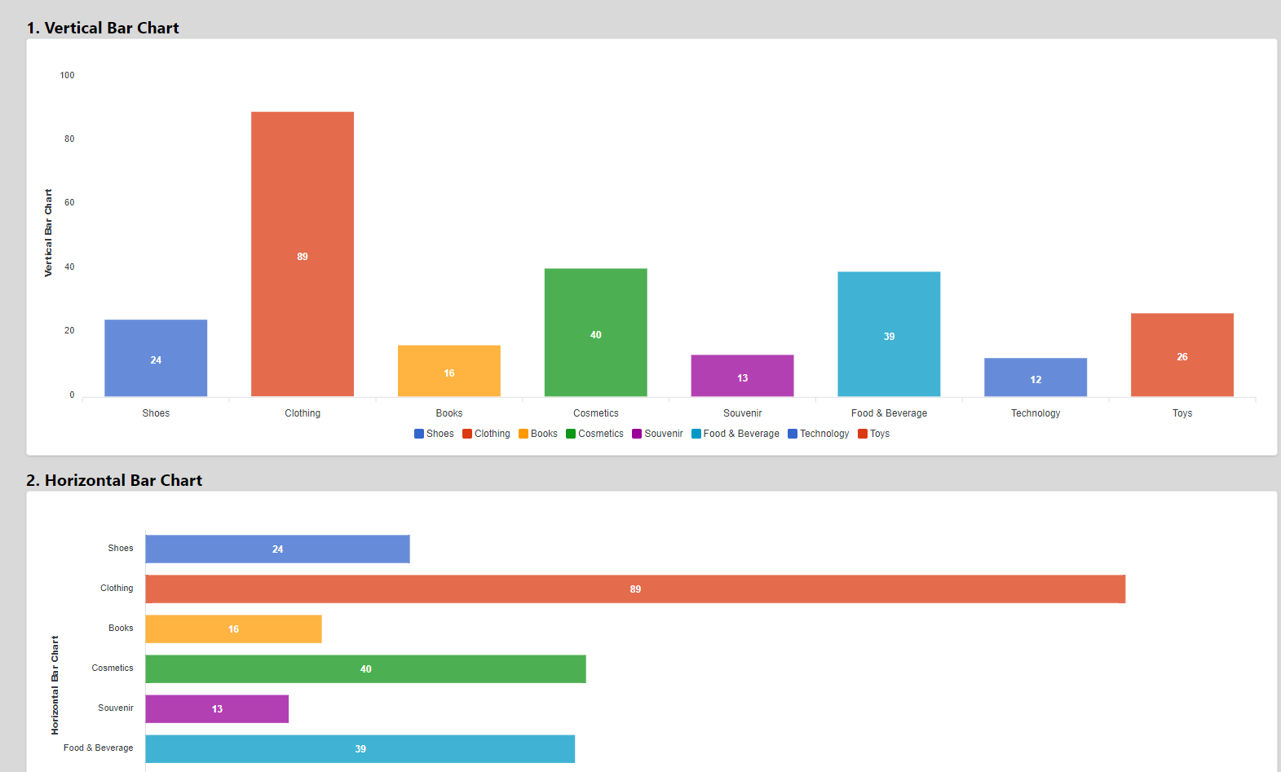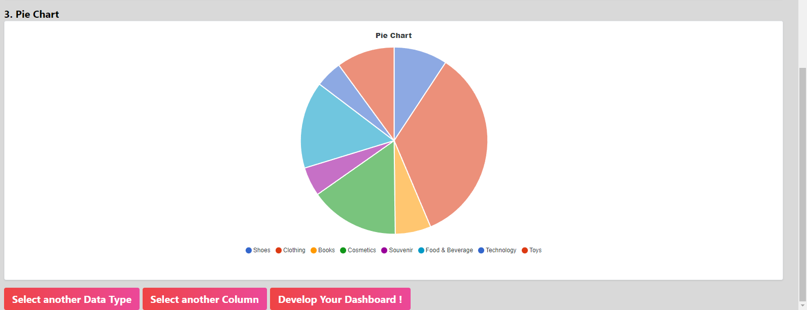

1. Then, there will be three buttons on the bottom, for the first button will be redirect back to the **No.7** page, for the second button will be redirect back to **No.9** page, and the develop your dashboard will be redirect to the next page.
2. If the user clicked on Develop your dashboard button, then it will be redirect to the next page where have Graph Configuration as below. 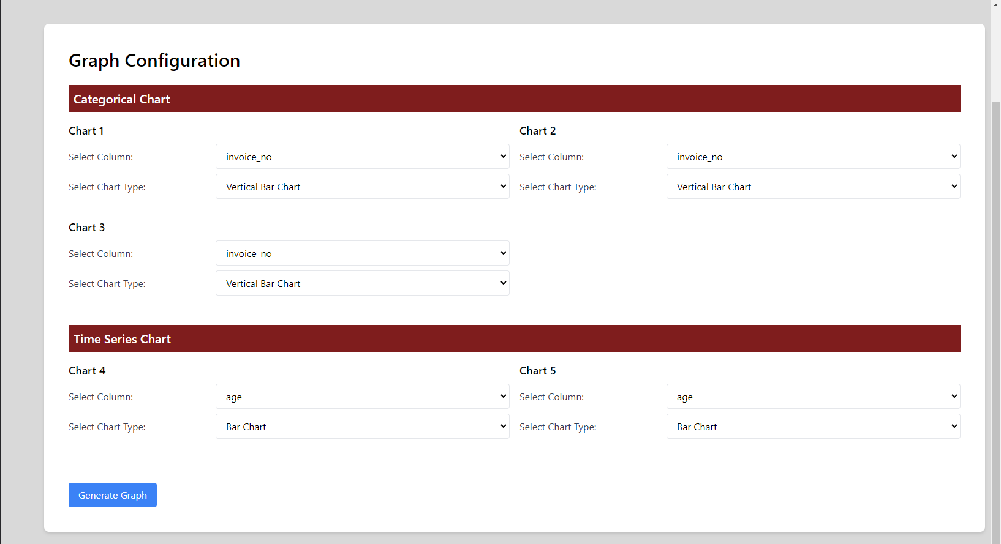
3. User have to select on chart 1 until 5, which column and what type of chart they want to display in their dashboard.

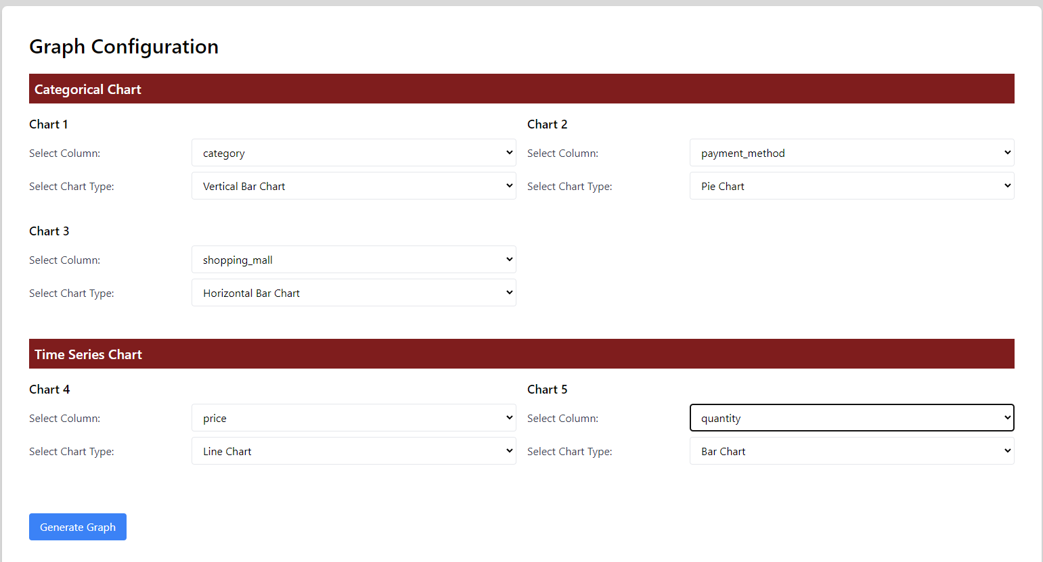

1. Then, the system will display the example of the dashboard by using the user’s dataset.

